**Class Diagram of Blood Bank Management System**

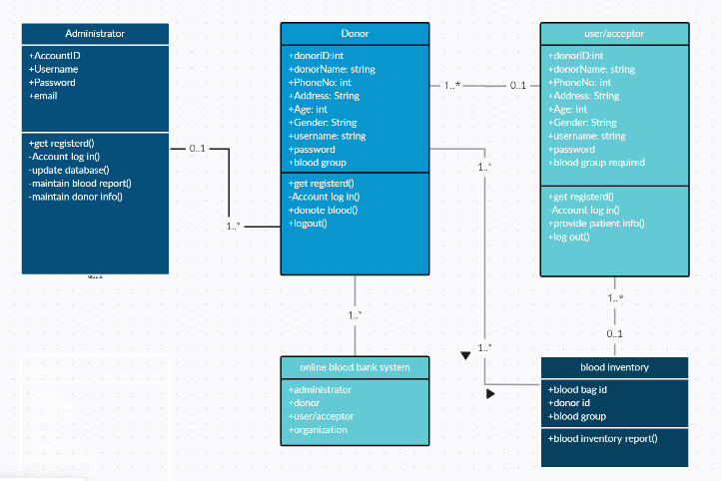

Classes included in following diagram:

* Donor,
* Receptionist,
* Doctor,
* Nurse,
* Lab technician,
* Blood,
* Blood bank,